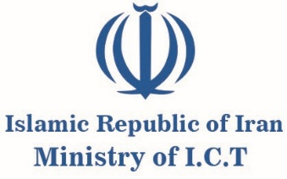

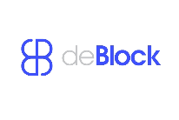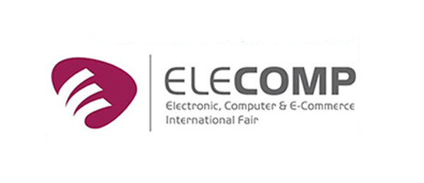

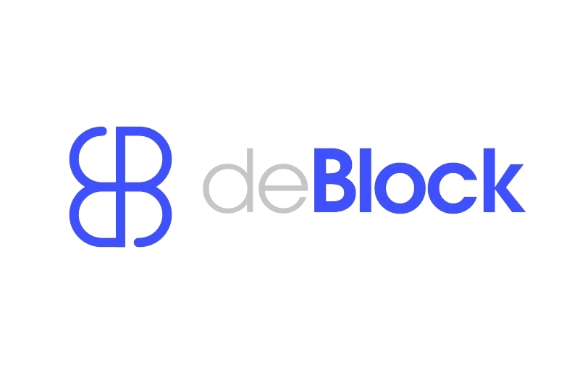Top of Form

Bottom of Form

Top of Form

**“Iran International Blockchain Conference (deblock)”, Tehran, 15-16 June 2025**

**and**

**the 28th “Iran International Exhibition of Electronics, Computer, E-Commerce” (ELECOMP), Tehran, 18-21 June 2025**

**Information Note**

**1. INFORMATION ABOUT EVENTS**

The 1st Iran International Blockchain Conference (deblock) will be held on June 15-16, 2025, in Tehran. Additionally, the 28th “Iran International Exhibition of Electronics, Computer, E-Commerce” (ELECOMP), scheduled to take place from the 18th to the 21st of June 2025 in Tehran.

**2. REGISTRATION FOR THE MEETING**

Every member of the participating delegations is required to complete the attached form (available at: <https://www.deblocksummit.org> and <https://iran-elecomp.com>) not later than May 31st 2025.

**3. VENUE OF EVENTS**

The deblock Conference will be held in " Iran International Conference Center” in Tehran. Meeting rooms for bilateral meetings will be provided to delegations upon written requests sent by e-mail to: [i.adeli@hotmail.com](mailto:i.adeli@hotmail.com)

**4. COORDINATOR OF THE EVENTS**

The Office for Interational Cooperation and Export Development of the Iranian Ministry of ICT

**5. Contact Persons:**

**Mr. Issa Adeli**, the Office for Interational Cooperation and Export Development /Tel. +982122817514 / E-mail: [i.adeli@hotmail.com](mailto:i.adeli@hotmail.com)

**6. VISA FORMALITIES**

All delegates are required to possess a valid passport with an expiration date of at least 6 (six) months prior to the date of entry into the territory of Iran. An entry visa will be issued by diplomatic missions or consular offices of the Islamic Republic of Iran. In case, there is no such missions or consular offices in your home contry, application for an entry visa may be submitted through <https://evisa.mfa.ir/en/>.

**7. ARRIVAL AND DEPARTURE OF DELEGATIONS**

Delegates will be received upon their arrival at the Imam Khomeini International Airport. Flight information shall be communicated in due course through the registration form to the contact persons. Private jets will be operated through Mehrabad International Airport in Tehran.

**8. LIAISON OFFICERS**

Each delegation will be provided with a Liaison Officer.

**9. HOSPITALITY FORMAT**

The host authority provides boarding and lodging in Espinas Palace Hotel as per the following format:

|  |  |  |
| --- | --- | --- |
| For Arrival | 1 nights | 2 Persons |
| For deblock Conference | 2 nights | 2 Persons |
| For Elecomp Exhibition | 1 nights | 2 Persons |

**10. ACCOMMODATION OF DELEGATIONS FOR MORE THAN 2 PERSONS**

The delegations will be accommodated according to the hospitality format at the Parsian Azadi Hotel Hotel. For reservation, please refer to:

Phone: + 98 21 29112

Fax: +98 21 22344478

Email: reservation@azadihotel.net

**11. WORKING LANGUAGE OF THE EVENTS**

The working language of the Events is English.

**12.** **DIETARY REQUIREMENTS**

Delegate Contact Persons are requested to complete and submit the registration form for any dietary restrictions as soon as possible. All efforts will be made by the Organizer to cater to dietary requirements throughout the event.

**13. WEATHER AND CLIMATE**

The average temperature is expected to be around 35-37° Celsius (Centigrade) during the event.

For further information, please refer to: <https://www.deblocksummit.org> and <https://iran-elecomp.com>